South Central FFA
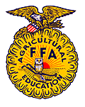

This certifies that

has earned the Appreciation Award for
assisting the South Central FFA Chapter and is entitled to this testimonial.

Given this 10th day of April 2013.

President’s Signature |  | Secretary’s Signature |  | Advisor’s Signature

